Reproducing Weighted Nuclear Norm Minimization for Image Denoising, with Colour, Variance-Stabilisation and Noise-Sensitivity Extensions
[Author 1 Name], [Author 2 Name]
[Department], KIIT
24155297@kiit.ac.in, [second author e-mail]
Highlight key: yellow = our contribution red = contribution of the original paper (Gu et al. [1]) and its released code

Abstract—We reproduce the weighted nuclear norm minimization (WNNM) image-denoising method of Gu et al. (CVPR 2014) in Python, starting from the authors’ MATLAB code. We compare the code with the paper, repair several defects in the public demo scripts, and numerically check the paper’s closed-form solution (Theorem 2), which holds only for ascending weights. On the House image our implementation reaches 36.87 dB at σ = 10 and 32.56 dB at σ = 30, within 0.1 dB of the published 36.95 dB and 32.52 dB. We add six small extensions. Optimal singular-value shrinkage and rank-aware aggregation do not improve on WNNM (−1.2 dB and −0.1 dB), which we report as negative results. An orthonormal opponent colour transform improves WNNM applied per RGB channel by 1.7 dB PSNR and 0.065 SSIM on average; luminance-guided grouping gives the same PSNR up to 1.4 times faster; a larger threshold on the chroma channels adds 0.2 dB, including on a held-out image; and Anscombe variance stabilisation adds 2.5 dB on average (0.4 to 5.5 dB) on synthetic signal-dependent noise, which follows the model it assumes. Two further studies show that WNNM is more sensitive than NNM to an under-estimated noise level (5.5 dB loss at 0.6 times the true σ) and that a key-patch stride of 4 is 3.7 times faster than the default at a loss of 0.01 dB. A ported noise-level estimator completes the pipeline for unknown noise.
Index Terms—image denoising, low-rank matrix approximation, weighted nuclear norm, non-local self-similarity, reproducibility
I. INTRODUCTION
Image denoising recovers a clean image x from y = x + n, where n is additive white Gaussian noise (AWGN) of standard deviation σ_{n}. The best classical methods exploit non-local self-similarity (NSS): small patches repeat across an image, so groups of similar patches can be denoised jointly [2], [3]. Stacking a group into a matrix makes that matrix approximately low rank, and nuclear norm minimization (NNM), the convex relaxation of rank [4], is a natural estimator. NNM shrinks all singular values by the same amount, even though the large singular values carry the image structure and should be shrunk less.
Gu et al. [1] therefore proposed weighted nuclear norm minimization (WNNM), which gives each singular value its own weight, and showed that it outperforms NNM and was competitive with or better than BM3D [2] and other state-of-the-art methods at the time. This project is a course reproduction of [1]. Our contributions are:
- a compact NumPy implementation (CPU only, batched SVD) checked line by line against the official MATLAB code and the paper, with the discrepancies and defects we found listed explicitly;
- a numerical check of the paper’s Theorem 2, which shows that the closed-form solution requires ascending weights and a factor-of-two convention;
- six simple extensions (optimal shrinkage, rank-aware aggregation, an opponent colour transform, luminance-guided grouping, chroma-aware thresholds, variance-stabilised denoising) evaluated with honest ablations, two of which turned out not to help;
- a ported noise-level estimator and a colour pipeline for images whose noise level is unknown;
- two practical studies: sensitivity to a wrong noise level, and the speed–quality trade-off of the key-patch stride and iteration count.
II. WEIGHTED NUCLEAR NORM MINIMIZATION
A. Problem and closed-form solution
For Y ∈ ℝ^{d×n} and a non-negative weight vector w, the weighted nuclear norm is ‖X‖_{w,*} = Σ_{i} w_{i} σ_{i}(X), where σ_{i}(X) are the singular values in descending order. WNNM solves
X̂ = arg min_{X} ½‖Y − X‖_{F}² + ‖X‖_{w,*}. (1)
Let Y = UΣV^{T} be the SVD. When the weights are ascending (w₁ ≤ … ≤ w_{n}, i.e. the largest singular value is penalised least), the solution is the generalised soft-thresholding [1]
X̂ = U S_{w}(Σ) V^{T}, S_{w}(Σ)_{ii} = max(Σ_{ii} − w_{i}, 0). (2)
Two remarks from our numerical check (Section V-A). First, the paper states Theorem 2 for non-ascending weights, but in our test the closed form is optimal only for ascending weights, which is also the order produced by (3) below and used in the official code. Second, with a data term ‖Y−X‖_{F}² without the ½, the exact threshold is w_{i}/2. The constant c below absorbs this factor, so the algorithm itself is unaffected.
III. WNNM DENOISING ALGORITHM
A patch group Y_{j} ∈ ℝ^{d×n} holds the n patches (each with d = p² pixels) most similar to a key patch, found by block matching in a search window. Since large singular values of the clean group X_{j} should be shrunk less, the weights are inversely proportional to them,
w_{i} = c√n / (σ_{i}(X_{j}) + ε), (3)
with ε = 10⁻¹⁶. The unknown σ_{i}(X_{j}) is initialised assuming the noise energy is spread evenly over the subspaces:
σ̂_{i}(X_{j}) = √max(σ_{i}²(Y_{j}) − nσ_{n}², 0). (4)
Because the estimated singular values are sorted, the weights are automatically ascending and (2) applies. Iterative regularisation feeds part of the removed noise back before every pass,
y^{(k)} = x̂^{(k−1)} + δ(y − x̂^{(k−1)}), (5)
and one iteration consists of block matching, weight estimation, SVD, shrinkage and averaging of all overlapping patch estimates (Algorithm 1 of [1]). The paper fixes δ = 0.1 and c = 2.8, and uses patch size 6, 7, 8, 9 with K = 8, 12, 14, 14 iterations for σ_{n} ≤ 20, ≤ 40, ≤ 60, > 60.
B. Details taken from the official code
The paper does not state several settings that matter in practice, so we follow the MATLAB code: n starts at 70/90/120/140 for the four noise ranges and is reduced by 10 at every re-matching; block matching is repeated every second iteration in a ±30-position window; only every ⌊p/2−1⌋-th patch is used as a group centre (the key-patch stride); the group mean is subtracted before the SVD; the weights are recomputed three times per group; the local noise level is re-estimated each iteration as λ·√|σ_{n}² − MSE|, with λ between 0.54 and 0.58; and the data term is normalised so that the implemented threshold is c√n σ_{n}²/(σ̂_{i}+ε), with c = 2√2 ≈ 2.83.
IV. IMPLEMENTATION AND EXTENSIONS
A. Implementation and fixes
We implemented the method in Python (NumPy 2.5, SciPy, scikit-image [9]) as a Jupyter notebook. Patch extraction uses sliding windows and all groups are processed in batches with a single batched SVD call, which removes the per-group loop of the MATLAB code. Compared with the public repository we fixed: (i) the demo script added noise with σ = 40 to a 0–1 image, producing meaningless output; (ii) the corrected index list in the block-matching function was computed but never used, so the key patch was not guaranteed to be first in its group, which we now enforce; (iii) hard-coded Windows paths and a swapped argument order in the PSNR call. Our key-patch grid always includes the last row and column, whereas MATLAB adds all remaining positions.
B. NNM baseline
The paper compares against NNM with “the uniform weight √nσ_{n}” without giving the exact constant. We use one threshold c_{nnm}√n σ_{n} for all singular values and chose c_{nnm} = 0.5 from {0.2, 0.3, 0.4, 0.5, 1, 1.5, 2} by a scan on two 128×128 crops at σ = 20 and 40. This is a tuned baseline and is stronger than the paper’s NNM.
C. Optimal singular-value shrinkage
WNNM sets thresholds with a heuristic weight. For a d×n matrix with i.i.d. noise of standard deviation σ, Gavish and Donoho [5] give the shrinker that is optimal for Frobenius loss. With q = max(d,n), β = min(d,n)/q and y = s/(σ√q), a singular value s is mapped to
ŝ = σ√q · √((y² − β − 1)² − 4β) / y if y > 1 + √β, else 0. (6)
It needs neither c nor the re-weighting loop. We evaluate it with the group noise level taken as is (κ = 1) and with a multiplier κ = 0.5, because overlapping patches in a group share noise and so are not i.i.d.
D. Rank-aware aggregation
When overlapping group estimates are averaged, each group receives weight g_{j} = 1/(1 + rank X̂_{j}) instead of 1, so that sparser (lower-rank) estimates count more, as in BM3D-style aggregation [2].
E. Opponent colour transform
The paper treats only grey images. Denoising R, G and B separately ignores their strong correlation. We first apply the orthonormal transform T with rows [1, 1, 1]/√3, [1, 0, −1]/√2 and [1, −2, 1]/√6, denoise the three resulting channels independently with WNNM, and apply T^{T}. Since T is orthonormal, white noise keeps the same standard deviation, so all channels use the same parameters, while the image energy is concentrated in the first (luminance-like) channel. This follows the luminance–chrominance idea of CBM3D [6]. For channels with different noise levels σ_{j} the new level is σ_{k}² = Σ_{j} T_{kj}² σ_{j}². We also tried stacking the three channels into one group matrix, which was about 4 dB worse in a preliminary test, because the initial estimate (4) assumes d ≤ n; we did not pursue it.
F. Luminance-guided grouping and chroma-aware thresholds
After the transform, the first channel carries almost all of the image structure, while the two chroma channels are nearly flat and mostly noise. We exploit this in two ways. (i) Luminance-guided grouping: block matching is done once, on the luminance channel only, and the resulting groups are reused for all three channels; each channel is still shrunk with its own SVD, so every group matrix keeps d ≤ n, unlike the stacked joint matrix mentioned above. This removes two thirds of the block matching and avoids matching on noisy chroma channels. (ii) Chroma-aware threshold: the constant c of (3) is multiplied by 1.5 for the two chroma channels, i.e. they are shrunk harder. The factor 1.5 was chosen from {1.5, 2} on two of our three colour crops (astronaut, chelsea); the third (coffee) was held out.
G. Noise-level estimation
For real images the noise level is unknown. As in the MATLAB repository we port the estimator of Liu et al. [7]: it keeps only weakly textured 7×7 patches, whose gradient energy lies below a chi-square threshold, and takes the smallest eigenvalue of their covariance as the noise variance, iterating three times. The estimate is passed to WNNM per channel.
H. Variance-stabilised denoising
Real sensor noise is closer to Poisson-Gaussian noise, whose variance grows with brightness, σ²(x) = ax + b. This violates the constant-σ model of WNNM. The generalised Anscombe transform (GAT) [10]
D = (2/a)√(ay + (3/8)a² + b) (7)
maps such noise to approximately unit-variance Gaussian noise. We (i) fit a and b per channel from the noisy image alone: the image is smoothed, only the flatter half of the pixels is kept (chosen by the gradient of the smoothed image, which does not depend on the noise level), the MAD-based variance of neighbouring-pixel differences is computed in 12 equal-count brightness bins, and a line is fitted; (ii) apply (7) and scale the result so that the noise std is 20 in every channel; (iii) denoise with the colour pipeline of Sections IV-E and IV-F, where all channels now have the same σ, so the opponent transform is exact; and (iv) apply the closed-form asymptotically unbiased inverse of [10]. A first version selected flat pixels from the magnitude of the noisy differences, which biased the fit toward low-noise pixels and gave about 30.5 dB instead of 35.6 dB on the coffee crop; the final version selects them from the smoothed image.
V. EXPERIMENTS
A. Setup and sanity checks
All experiments ran on a 2-core CPU without GPU. Noise is Gaussian with a fixed seed (one realisation per setting). PSNR uses a peak of 255 and no clipping, like the MATLAB code; SSIM [8] is computed with scikit-image and therefore differs slightly from the MATLAB SSIM script. House (256×256) comes from the official repository; all other tests use 128×128 crops of images bundled with scikit-image (camera, coins, astronaut, chelsea, coffee), because the full-size runs are slow on a CPU (one House run takes about 65 s at σ = 10 and 145 s at σ = 30). The paper’s 20-image benchmark is not available to us.
We checked that patch extraction and aggregation are exact inverses and that block matching returns the key patch first. We also tested Theorem 2 on a 5×4 matrix with close singular values (5, 4.8, 4.6, 4.4) by comparing the closed form with a numerical optimiser (Powell, 10 starts) on ½‖Y−X‖_{F}² + ‖X‖_{w,*}. For ascending weights (0.2, 1, 2, 3) both give an objective of 21.18. For descending weights (3, 2, 1, 0.2) the closed form gives 30.02 while the optimiser reaches 24.54, so the closed form is not optimal there.
B. Reproduction on House
Table I compares our results with Table 1 of [1]. WNNM is within 0.1 dB of the published values at both noise levels. Our NNM is 0.4–0.8 dB higher than the published NNM because we tuned its threshold, so our WNNM-over-NNM gain (0.5 and 0.8 dB) is smaller than the published 1.0 and 1.5 dB; WNNM is nevertheless better in both cases. Fig. 1 shows an example.
TABLE I
PSNR (dB) on House (256×256). “Paper” values are from Table 1 of [1].
σ | Noisy | NNM (ours) | NNM (paper) | WNNM (ours) | WNNM (paper) | Gain (ours)
10 | 28.14 | 36.35 | 35.97 | 36.87 | 36.95 | 0.52
30 | 18.59 | 31.77 | 30.99 | 32.56 | 32.52 | 0.79

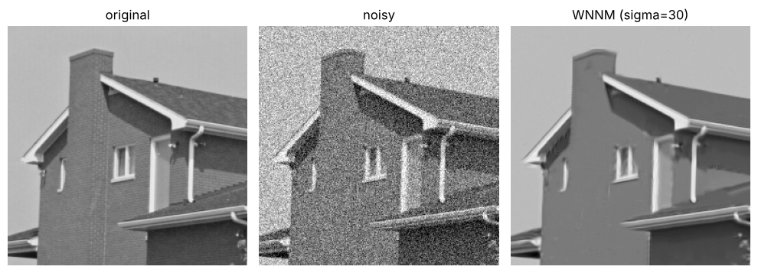
Fig. 1. House, σ = 30. Left to right: original, noisy (18.59 dB), WNNM result (32.56 dB).
C. Optimal shrinkage and rank-aware aggregation
Table II reports PSNR on three 128×128 grey crops. Optimal shrinkage with κ = 1 is 1.2 dB below WNNM on average. With κ = 0.5 it ties with WNNM (29.28 vs. 29.29 dB), but κ was chosen by us on the same images, so this is not an improvement. Rank-aware aggregation is 0.1 dB worse. Neither extension improves WNNM; in a small preliminary test on two crops (not tabulated), using the previous estimate to initialise the weights, matching on a lightly blurred estimate (Gaussian σ = 0.6) and changing c to 2.4 or 3.2 all stayed within ±0.05 dB of the default, and a stronger blur (σ = 1) lost up to 0.2 dB.
TABLE II
PSNR (dB) on 128×128 crops. OS: optimal shrinkage; OS-.5: with κ = 0.5; RA: WNNM with rank-aware aggregation.
σ / image | NNM | WNNM | OS | OS-.5 | RA
20 / house | 32.05 | 32.44 | 31.65 | 32.42 | 32.20
20 / camera | 29.58 | 30.42 | 29.16 | 30.41 | 30.35
20 / coins | 28.90 | 29.50 | 28.26 | 29.52 | 29.46
40 / house | 29.24 | 30.05 | 28.57 | 30.01 | 29.80
40 / camera | 25.98 | 26.79 | 25.27 | 26.79 | 26.69
40 / coins | 25.99 | 26.51 | 25.38 | 26.55 | 26.53
Mean | 28.62 | 29.29 | 28.05 | 29.28 | 29.17

D. Colour images
Table III compares WNNM applied to each RGB channel with WNNM in the opponent space, on two 128×128 colour crops. The opponent transform improves PSNR by 1.3 to 1.9 dB (1.7 dB on average) and SSIM by 0.065 on average. Fig. 2 shows that the per-RGB-channel result keeps visible colour noise, which the opponent version removes.
TABLE III
Colour denoising: WNNM per RGB channel vs. opponent space (ours).
σ | Image | RGB (dB) | Opp. (dB) | Gain | RGB SSIM | Opp. SSIM
20 | astronaut | 29.78 | 31.56 | 1.78 | 0.882 | 0.917
20 | chelsea | 29.40 | 31.25 | 1.85 | 0.776 | 0.858
40 | astronaut | 26.60 | 28.35 | 1.74 | 0.789 | 0.851
40 | chelsea | 26.89 | 28.21 | 1.32 | 0.655 | 0.735
Mean |  | 28.17 | 29.84 | 1.68 | 0.775 | 0.840

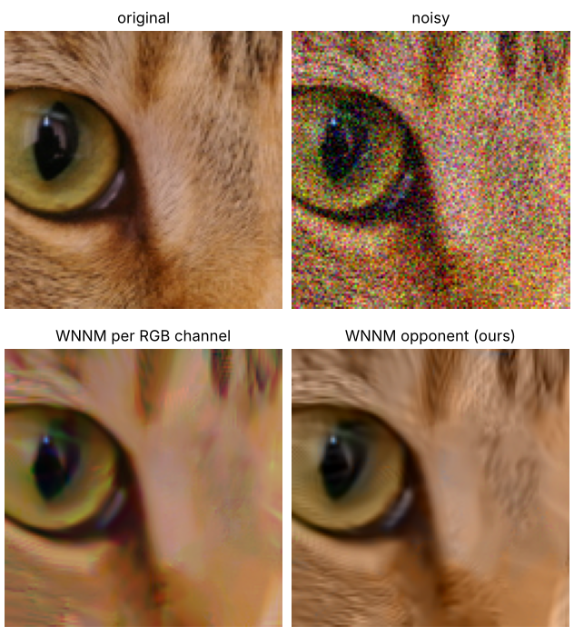
Fig. 2. Chelsea crop, σ = 40. Top: original, noisy. Bottom: WNNM per RGB channel (26.89 dB), WNNM in opponent space (28.21 dB).
E. Luminance-guided grouping and chroma-aware thresholds
Table V compares independent opponent-space WNNM with luminance-guided grouping (“Shared”) and with the added chroma threshold. Shared grouping leaves PSNR essentially unchanged (mean +0.02 dB; per-case changes from −0.14 to +0.21 dB) and is 1.07 to 1.37 times faster (wall-clock times depend on machine load; the speed-up is larger at σ = 40). The chroma factor adds +0.09 to +0.46 dB in all six cases, with the largest gains on the held-out coffee crop (+0.34 and +0.46 dB). With three crops and one noise realisation each, we regard this gain as consistent but modest.
TABLE V
Colour PSNR (dB) with opponent transform. Shared: luminance-guided grouping; +chr.: plus chroma threshold factor 1.5; gain is relative to independent channels. * held-out image.
σ / image | Indep. | Shared | Sh.+chr. | Gain | Speed-up
20 / astronaut | 31.56 | 31.56 | 31.65 | 0.10 | 1.07×
20 / chelsea | 31.25 | 31.28 | 31.35 | 0.10 | 1.09×
20 / coffee* | 34.98 | 35.18 | 35.31 | 0.34 | 1.09×
40 / astronaut | 28.35 | 28.21 | 28.43 | 0.09 | 1.30×
40 / chelsea | 28.21 | 28.21 | 28.34 | 0.13 | 1.34×
40 / coffee* | 31.79 | 31.79 | 32.25 | 0.46 | 1.37×
Mean | 31.02 | 31.04 | 31.22 | 0.20 | 1.20×

F. Noise-level estimation and real-type noise
Table IV shows that the estimator is accurate on Gaussian noise (House). We could not test real camera noise, as no internet access or real noisy dataset was available. As a proxy we added signal-dependent noise (standard deviation √(a·x + b), different per channel) to a 128×128 colour crop and ran the full pipeline: estimate σ per channel, then denoise in the opponent space. The estimates were 19.3, 17.2 and 12.3 for R, G, B against average true levels of 19.8, 19.0 and 16.6, so the estimator under-estimates the noise in bright channels because it measures flat, mostly dark patches. Even so, PSNR rose from 22.77 to 30.98 dB and SSIM from 0.417 to 0.835 (Fig. 3).
TABLE IV
Estimated noise level on House with AWGN.
True σ | Estimated σ | Error
5 | 5.03 | +0.03
10 | 9.85 | −0.15
20 | 19.57 | −0.43
40 | 38.89 | −1.11

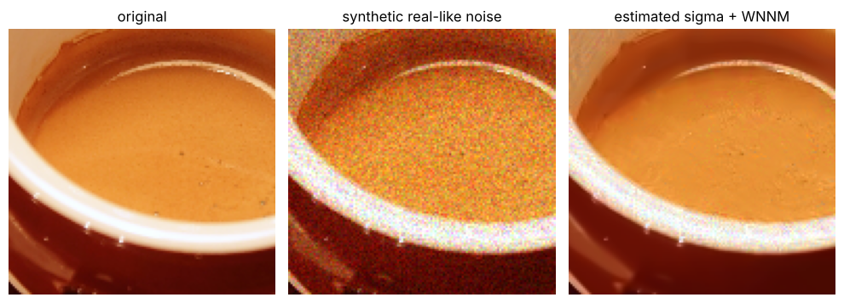
Fig. 3. Synthetic signal-dependent noise (coffee crop). Left to right: original, noisy (22.77 dB), estimated σ + WNNM (30.98 dB).
G. Variance-stabilised denoising
We added signal-dependent noise (standard deviation √(ax + b), different per channel) at two strengths to three 128×128 colour crops and compared the previous pipeline (one estimated σ per channel, now including the luminance-guided grouping and chroma threshold, so the coffee value differs slightly from Section V-F) with the stabilised pipeline of Section IV-H. Table VI shows that stabilisation improves PSNR in all six cases, by 0.4 to 5.5 dB (mean 2.5 dB), and SSIM from 0.813 to 0.878 on average. The gain differs strongly between images and is smallest for the chelsea crop at mild noise (+0.4 dB, SSIM unchanged); we did not investigate why. On the coffee crop, using the true a and b instead of the fitted ones gives 35.61 dB instead of 35.59 dB (mild) and 33.35 dB instead of 33.08 dB (strong), so the fitting step loses little. Because the noise follows the model of the transform exactly, this test favours the method; the gain on real photographs will be smaller and remains to be tested.
TABLE VI
Signal-dependent noise: plain pipeline vs. variance-stabilised (GAT) pipeline.
Noise / image | Plain | GAT | Gain | Plain SSIM | GAT SSIM
mild / astronaut | 30.29 | 31.84 | 1.55 | 0.873 | 0.925
mild / chelsea | 31.35 | 31.73 | 0.37 | 0.866 | 0.867
mild / coffee | 31.21 | 35.59 | 4.38 | 0.839 | 0.918
strong / astronaut | 27.14 | 29.44 | 2.30 | 0.783 | 0.880
strong / chelsea | 28.66 | 29.68 | 1.02 | 0.775 | 0.802
strong / coffee | 27.57 | 33.08 | 5.50 | 0.743 | 0.874
Mean | 29.37 | 31.89 | 2.52 | 0.813 | 0.878

H. Sensitivity to a wrong noise level
In practice σ is estimated. We denoised 128×128 crops of House and Camera with true σ = 20 but told the algorithm a different value (the parameter set, i.e. patch size, patch count and iterations, changes with it, as it would with an estimated σ). Table VII gives the mean PSNR. Under-estimation hurts more than over-estimation, and it hurts WNNM more than NNM: at 0.6 times the true σ WNNM loses 5.5 dB and NNM 2.9 dB, and NNM is then 2.0 dB better than WNNM. WNNM is 0.6 to 0.8 dB better than NNM when σ is correct or over-estimated. In practice this favours erring slightly on the high side: a 20% over-estimate costs 0.7 dB, a 20% under-estimate 1.7 dB. Part of the effect comes from the parameter set changing with the assumed σ.
TABLE VII
Mean PSNR (dB) of two crops when the assumed σ differs from the true σ = 20.
Assumed σ | WNNM | NNM | WNNM Δ | NNM Δ
12 (0.6×) | 25.96 | 27.94 | −5.48 | −2.88
16 (0.8×) | 29.78 | 29.98 | −1.66 | −0.84
20 (1.0×) | 31.43 | 30.82 | 0.00 | 0.00
24 (1.2×) | 30.69 | 29.92 | −0.74 | −0.90
28 (1.4×) | 29.81 | 29.13 | −1.62 | −1.69

I. Speed–quality trade-off
Table VIII varies the key-patch stride and the number of iterations K at σ = 20 on two 128×128 crops (default: stride 2, K = 8). Strides 3 and 4 give the same PSNR as the default (31.44 and 31.42 dB against 31.43 dB) and are 2.2 and 3.7 times faster; stride 1 is four times slower without any gain; stride 6 loses 0.13 dB. Halving the iterations to K = 4 costs 0.14 dB and saves 42% of the time. Times are single measurements on a 2-core CPU.
TABLE VIII
Mean PSNR (dB) and run time per 128×128 image at σ = 20. * default.
Setting | PSNR | Seconds
stride 1 | 31.43 | 64.1
stride 2 * | 31.43 | 16.4
stride 3 | 31.44 | 7.4
stride 4 | 31.42 | 4.4
stride 6 | 31.30 | 1.9
K = 2 | 29.98 | 4.6
K = 4 | 31.29 | 9.3
K = 6 | 31.40 | 12.5
K = 8 * | 31.43 | 16.0

VI. DISCUSSION
The reproduction supports the main claim of [1]: weighting singular values inversely to their size gives a clear gain over uniform shrinkage, and our code matches the published House numbers closely. The negative results are informative. The optimal shrinker is derived for a low-rank matrix plus i.i.d. noise, but patch groups are not exactly low rank and overlapping patches share noise, so the effective noise level is probably overstated and the shrinker removes too much (a multiplier of 0.5 closes the gap, but at the cost of an extra tuned parameter; we did not test this explanation further). Rank-aware aggregation assumes that lower-rank groups are more reliable, which evidently did not help here. The opponent colour transform works because it is orthonormal (the noise model of WNNM is unchanged) and decorrelates the channels. The chroma threshold result is consistent with chroma channels holding little structure, so harder shrinkage costs little there; we did not test this explanation separately. Variance stabilisation helps most when the noise level changes strongly with brightness; the fitted noise curve was almost as good as the true one, so the fitting step is not the bottleneck. The sensitivity study shows that an accurate noise-level estimate matters more for WNNM than for NNM, probably because WNNM uses the assumed σ twice (in the initial singular-value estimate and in the weights); we did not test this.
Limitations: the chroma factor was picked from only two values; the variance-stabilisation test uses synthetic noise that matches the transform; the sensitivity and trade-off studies use two crops, one σ and one noise realisation, and the run times are single measurements; only one full-size image (House) and two noise levels were compared with the paper; the other tests use small crops; each setting uses one noise realisation, so differences below about 0.1 dB should not be over-interpreted; no other denoisers (BM3D, EPLL, LSSC, NCSR, SAIST) were run; SSIM differs from the MATLAB implementation; and no real photographs were tested.
VII. CONCLUSION
We reproduced WNNM image denoising in Python, within 0.1 dB of the published House results, documented the gaps between paper and code, and corrected the issues we found in the public scripts. Of six extensions, four help: the opponent transform (+1.7 dB over per-channel RGB), chroma-aware thresholds (a further +0.2 dB on average), luminance-guided grouping (up to 1.4 times faster at equal PSNR) and, on synthetic signal-dependent noise, variance stabilisation (+2.5 dB on average); optimal shrinkage and rank-aware aggregation do not beat WNNM. We also showed that an under-estimated noise level is the costlier mistake and that a coarser key-patch stride saves most of the run time at almost no loss. Future work includes the full 20-image benchmark, real noisy datasets (to test variance stabilisation on real camera noise), and a joint colour grouping that handles groups with more rows than columns.
REFERENCES
[1] S. Gu, L. Zhang, W. Zuo, and X. Feng, “Weighted nuclear norm minimization with application to image denoising,” in Proc. IEEE Conf. Comput. Vis. Pattern Recognit. (CVPR), 2014, pp. 2862–2869.
[2] K. Dabov, A. Foi, V. Katkovnik, and K. Egiazarian, “Image denoising by sparse 3-D transform-domain collaborative filtering,” IEEE Trans. Image Process., vol. 16, no. 8, pp. 2080–2095, Aug. 2007.
[3] A. Buades, B. Coll, and J.-M. Morel, “A non-local algorithm for image denoising,” in Proc. IEEE Conf. Comput. Vis. Pattern Recognit. (CVPR), 2005, vol. 2, pp. 60–65.
[4] J.-F. Cai, E. J. Candès, and Z. Shen, “A singular value thresholding algorithm for matrix completion,” SIAM J. Optim., vol. 20, no. 4, pp. 1956–1982, 2010.
[5] M. Gavish and D. L. Donoho, “Optimal shrinkage of singular values,” IEEE Trans. Inf. Theory, vol. 63, no. 4, pp. 2137–2152, Apr. 2017.
[6] K. Dabov, A. Foi, V. Katkovnik, and K. Egiazarian, “Color image denoising via sparse 3D collaborative filtering with grouping constraint in luminance-chrominance space,” in Proc. IEEE Int. Conf. Image Process. (ICIP), 2007, pp. I-313–I-316.
[7] X. Liu, M. Tanaka, and M. Okutomi, “Single-image noise level estimation for blind denoising,” IEEE Trans. Image Process., vol. 22, no. 12, pp. 5226–5237, Dec. 2013.
[8] Z. Wang, A. C. Bovik, H. R. Sheikh, and E. P. Simoncelli, “Image quality assessment: From error visibility to structural similarity,” IEEE Trans. Image Process., vol. 13, no. 4, pp. 600–612, Apr. 2004.
[9] S. van der Walt et al., “scikit-image: Image processing in Python,” PeerJ, vol. 2, p. e453, 2014.
[10] M. Mäkitalo and A. Foi, “Optimal inversion of the generalized Anscombe transformation for Poisson-Gaussian noise,” IEEE Trans. Image Process., vol. 22, no. 1, pp. 91–103, Jan. 2013.

